**Web Analyzer and Classifier**

*Final report submitted in partial fulfillment of the requirements for*

*The award of the degree of*

**Master of Computer Applications**

LOGO

By

**XYZ**

**(1234)**

**Department of Computer Science**

**College Name**

**University Name**

**April 2021**

**CANDIDATE’S DECLARATION**

I **XYZ** hereby certify that all of the work, which is being presented in the project report, entitled **Web Analyzer and Classifier** in partial fulfillment of the requirement for the award of the Degree of **Master of Computer Applications** and submitted to the institution is an authentic record of my own work carried out during the period January, 2021 to April, 2021 under the supervision of **Dr. ABC**. I also cited the reference about the text(s) /figure(s) /table(s) /equation(s) from where they have been taken.

The matter presented in this report as not been submitted elsewhere for the award of any other degree or diploma from any Institutions.

**Date: Signature of the Candidate**

This is to certify that the above statement made by the candidate is correct to the best of my knowledge. The Viva-Voce examination of X**YZ**; M.C.A. Student has been held on _________________.

|  |  |  |
| --- | --- | --- |
| **Signature of** |  | **Signature of** |
| **Research Supervisor** |  | **Head of the Department** |

**ACKNOWLEDGEMENT**

I am very happy because I am successful submit my Final report of this project ‘Web Analyzer and Classifier ’. It is very difficult for me to complete my project but this project is successfully done because of some people help me a lot. I am really thankful for some teachers and my friends who help me in this project .I would like to express my special thanks to my project teacher and supervisor “Dr. ABC sir” which guidance is more important for me.

I would also thankful for Head of the department “DEF” for providing me this opportunity and also provide all facilities for complete my project work.

I am very lucky to get such as good project. I sure about this project is very useful for academic purpose and industrial purpose also..

**ABSTRACT**

Web analyzer is a software or tool that downloads and extracts data from the website. After the downloading, it analyzes data and also classifies data for many purposes like advertisement, web archiving and page analysis etc. This project works into basic of python programming. This project leverages some python libraries like nltk for natural language processing, matplotlib.pyplot for plotting, word.tokenizer, sent.tokenizer, stopwords for word processing, beautifulSoup for web scraping and flask as a web framework etc. In this project, firstly we download all data from the divisions, paragraphs, heading and images from two websites called <http://VaranasiKshetra.com> and <http://film.list.co.uk/listings/amitabh-bachchan/> ,it is done by web scraping because web scraping divides the website contents into scraps(parts ) and after we downloaded data we converts all data into sentences list and words list by using library sentence_tokenizer and word_tokenizer from nltk. Now we produce frequencies for words list by using nltk.FreqDist .Then we plot a graph between words and frequency by using the python library

matplotlib.pyplot .This words list have very irrelevant words so we can remove this words by using stopwords library .After the removing all stopwords we get again a words list. Now we again repeat all process like produce frequency and make plot for frequency and words list.

Now we take a sample (training set) which is needed for some purpose then we find the intersection between words list and training set it is easily done by call intersection() method in python. Now we produce the words list and frequency list of intersection set. After getting frequency and words set we plot a graph between frequency and words of intersection set.

This process does for so many training sets. Finally we get similarities between all training set and website page by comparing the words and frequencies of both. If similarity between first training set and web page is greater than other training then we say that first training set is more preferable than other. So the goal of this project is to find the content (which training set) is more similar than web page.

**TABLE OF CONTENTS**

**Title Page No.**

ACKNOWLEDGMENT……………………………………………………………………iii

ABSTRACT iv

LIST OF FIGURES vi

**CHAPTER 1** **INTRODUCTION**

* 1. Web analyzer and Web analysis ...................................................................................1

1.2 Varanasikshetra.com 1

1.3 https://film.list.co.uk/listings/amitabh-bachchan.........................................................1

**CHAPTER 2** **TOOLS AND TECHNOLOGY USED**

1. Basic Python………………………………………………………………………..... 2
2. Pickle in python 3
3. Graph plot in Python…………………………………………………………………..4
4. Web Scraping …………………………………………………………………………5
5. Beautiful Soup…………………………………………………………………………5
6. Flask ………………………………………………………………………………….. 6
7. NLP(Natural Language Processing)……………………………………………………7
8. Bootstrap……………………………………………………………………………….8

**CHAPTER 3** **WORK DONE (PROGRESS**)…………………………………......10

**CHAPTER 4 CONCLUSION AND FUTURE SCOPE**

* 1. Result 33
  2. Conclusion 33
  3. Scope for Future Work…………………………………………………………..34

**CHAPTER 5** **REFERENCES**……………………………………………………..35

**LIST OF FIGURES**

**Figure No.** **Title** **Page No**.

1. Matplot Example .5
2. Amitabh Bachchan Blog .10
3. Frontpage of site Web Analyzer (forAmitabh Bachchan blog)…………………………………..11
4. Sentence list forAmitabh Bachchan Blog………………………………………………………………….12
5. Word list for Amitabh Bachchan Blog……………………………………………………………………….13
6. Words of frequencies for Amitabh Bachchan Blog………………………………………………… .14
7. Frequency graph for Amitabh Bachchan Blog……………………………………….15
8. Stopwords for Amitabh Bachchan Blog……………………………………………..15
9. Word list after remove Stopwords (Amitabh Bachchan Blog)……………………….16
10. Frequency dictionary for Amitabh Bachchan Blog………………………………….16
11. Frequency graph after removing Stopwords for Amitabh Bachchan Blog……………..17
12. Convert words list into Set for Amitabh Bachchan Blog……………………………………......18
13. First training Set for Amitabh Bachchan Blog……………………………………....18
14. Intersection Set for Amitabh Bachchan Blog……………………………………………….………....19
15. Frequencies and words in Intersection Set for Amitabh bachchan Blog……………..19
16. Plot graph of Intersection Set 1for Amitabh bachchan Blog………………………………..….19
17. Second training Set for Amitabh bachchan Blog…………………………………………………….20
18. Intersection Set2 for Amitabh bachchan Blog………………………………………………………..20
19. Plot graph of Intersection Set2 for Amitabh bachhan Blog……………………………………20
20. Varanasikshetra .21
21. Front page of site Web Analyzer (for Varanasikshetra) .22
22. Sentence list for varanasikshetra website...... .23
23. Words list for VaranasiKshetra website……………………………………………..24
24. Words of frequencies for Varanasikshetra website…………………………………………………25
25. frequency graph for Varanasikshetra Website 26
26. Stopwords for Varanasikshetra…………………………………………………………………………………26
27. Word list after remove Stopwords for Vanaransikshetra………………………………………….27
28. Frequency Dictionary for Varanasikshetra website……………………………………………………28
29. Frequency graph after removing Stopwords for Varanasikshetra……………………..29
30. Convert words list into Set for Varanasikshetra………………………………………30
31. First training Set for Vranasikshetra website……………………………………………………………..30
32. Intersection Set for Varanasikshetra website……………………………………………………………31
33. Frequencies and wordsinIntersection Set for Varanasikshetra Website……………………31
34. Plot graph of Intersection Set1 for Varanasikshetra website…………………………………….31
35. Second training Set for Varanasikshetra website………………………………………………………32
36. Intersection Set2 for Varanasikshetra website………………………………………………………….32
37. Plot graph of Intersection Set2 for Vranasikshetra website………………………………………32

**CHAPTER 1**

**INTRODUCTION**

**1.1 Web analyzer and Web analysis:**

Web analyzer is software that is used to retrieve and extract data (or information) from any website and analyze the data for general purpose .

Web analyzer is a simple but powerful website analyzing tool that helps us to download or retrieved the information from this and then we analyze the data.

Since internet is very large, complex and ever-evolving.and this more bigger so much in few years this data may be very large. So we need to this data must be customized In web analyzer we use web scraping for customizing the data. In web scraping we reduce the all stopwords and this like irrelevant content. The outcome of everyone equipped to crawl, scrape, and extract, is unnecessary waste of precious man-power. Collaborative scraping could well heal this hurt. Here, where one web crawler does a broad scraping, the others scrape data off an API. An extension of the problem is that text retrieval attracts more attention than multimedia; and with websites becoming more complex, this enforces limited scraping capacity.

**1.2 Varanasikshetra:**

Varanasikshetra is a website that gives us a brief introduction about Varanasi. It renders about the rich heritage and the culture of this holy city of Varanasi. It gives us a walkthrough about the grand old and famous Panchkoshi Parikrama, It gives us a vast portrayal and description about the temples here, It depicts about the festivals celebrated in Varanasi and much more. We can also see a section that gives us information that can be uselful to not only us but for the tourists as well, the information about the hotels in the city and the flights coming to Varanasi. BHU, being in Varanasi is what motivated me to pick this website and to collect information about this historic and cultural city.

I select this because for my project because this is an open website So I can easily retrieved data from this website and It helps to many people for know about Varanasi city and It gives actual purpose for why we visit Varanasi city and why we spend time in Varanasi city.

1.3  **Amitabh-bachchan Blog**

This page contains information about the film superstar Amitabh Bachchan . His films and his career. We use this page to check our classification for film pages.

**CHAPTER 2**

**TOOLS AND TECHNOLOGY USED**

* 1. **Basic Python:**

Python is an object oriented; structured and general purpose scripted programming language. It is use for scripting .A program is executed but a ‘script’ is interpreted and python language codes are ‘script’. A scripting language is a type of programming language where we can write code control another software programming. It is also known as interpreter because we can check its code line by line. Python codes are look like uncomplicated and uncluttered but it highly readable. Python is multi paradigm language .Multi paradigm allows developer to code in several platforms. Scripting in python is also used for creating Game menu applications. Python have large scale of web servers that provides uninterrupted services. So python is one of the most popular dynamic programming language.

**Advantages of Python**

Python require less number of line of code is less compared to other languages like

C. So less programming errors and also reduces time for developing code.

Python can be used for large variety of tasks like Development mobile apps, desktop apps, game programming and also network programming.

Python have cross platform language capability which means that the code written for one operating system like Windows, and we will work equally with Linux or MacOs without any changes to the python code.

Firstly python is introduced by Guido Van Rossum in early 1980s in Netherlands for implementing the ABC Programming language. He used python for searching a scripting language as look like syntax of ABC with help of Amoeba system calls access. The ABC programming language was most of the playing role for designed and development of Python programming language. The idea of design python like a new and simple scripting language overcomes from ABC programming language. Its implementation was started in December, 1989.The first version of a new programming language was released in 1991.

The Python logo designed by picture of two snakes blue and yellow so it will not be incorrect to if people connect this with the snake python but its named python behind a different story .

G.V Rossum was a very big fan of ‘Monty Python’s Flying Circus’ in 1970s this is a big comedy TV show in Netherlands so he named his programming project as Monty Python.

Python is open source from beginning. Python first version is proposed in year 1991 and this version named as ‘Python 1.0’.Now day’s versions are upgraded into Version 3.x.

Python is used in developing web Programming Applications like Web servers; it is used for developing applications, for connecting to database and accessing data.

All of the above Python is used in doing complex mathematics and therefore is an invaluable tool for developing Machine Learning and Big Data apps.

Python has a very concise, readable and English like syntax. Python is interpreted, this makes it very easy to debug and also it supports the method of incremental development. Python can be used in a procedural fashion or an object oriented way.

The object oriented featured of Python is very dynamic. Fields, methods etc can be added and removed at runtime.

Python is modular. This means that Python code can be stored in different files and these modules can be added or removed as required.

Python Programming can be done in many IDEs including Eclipse and Net beans. We will start out with Anaconda and its Python IDE Spider.

Basic topics covers in python Keywords, identifiers, Statements, Comments, Variables, Data types, Type Conversion, IO, Operators, If Else, Loops( for, while, break, continue) ,Functions( arguments and parameters, anonymous functions, recursion), Data types(List, Tuple, String, Set, Dictionary, Arrays, Matrix),Object Oriented Python(Inheritance, Multiple Inheritance, File Handling etc.)

**2.2 Pickle in python:**

Pickling is a method that to convert a python object like list, dictionary etc. into a character stream. Why we convert an object in character stream because character stream contains all the necessary information to reconstruct the object in another python script. It is a process of converting obj into byte stream to be written on file known as serialization. It is used for where some applications need some degree of persistency in your data. It is mainly used for serializing and de-serializing a python object.

Pickle is also used de-serializing a Python object structure and de-serializing is called as un-pickling. Any type of object can be pickled so we could all object saved on disk. Pickle serializes the object first before writing it to file.

**Syntax: import pickle as p**

For read and write from a file we need to firstly open the file. This is done by some open function in python.

**Example 1:-**

import pickle as p

l=[65,78]

print(l)

f=open(“E:/savedata/listl.txt”, “wb”)

p.dump(l,f)

f.flush()

f.close()

**How to work this program?**

Firstly we are open file by its file name and path (address) .

The file access mode is “wb”= write binary. The dump function in Python writes the object to the file stream. The flush method of the file transfers all data to the stream (in this case the file). The close method writes EOF and sets f to null.

Now when for reading of this file we shall use bellow codes

Import pickle as p

f=open(“E:/savedata/listl.txt”, “rb”)

x=p.load(f)

print(x)

**2.3** **Graph plot in Python :**

For produce graph plots in Python firstly we will be importing the pyplot module from matplotlib . matplotlib.pyplot is a collection of command style functions that produce a library of math function look like “Matlab”. It is used for plotting a graph between x and y axis.

It is useful for creates a figure, plotting area in a figure and plots some line in a plotting area etc.

**Syntax:**

import matplotlib.pyplot as pt

**Example**-

Import matplotlib.pyplot as pt

X=[1,2,3]

Y=[1,4,9]

pt. plot(x,y)

pt.xlabel(“x-axis”)

pt.ylabel(“y-axis”)

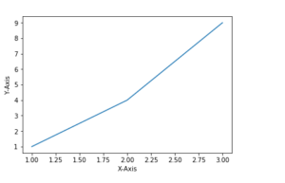

1.1 Matplot Example

**2.4 Web Scraping library in Python:**

In beginning firstly we know about Scraping then we go for Web Scraping. So, what is Scraping? Scraping is a process that converting unstructured documents into structure document. Now we go for Web Scraping, Web Scraping or eb Harvesting is a software technique which is used extracting information from the web servers. It will help analyzed and stored data (or information) into unstructured data to structured data.

Many places it is called as data mining and web harvesting. Web Scraping is a library of the Python. This library will download the information from web server and analyze all information into many different parts. Web Scraping is a process of constructing an agent which can extract and download of useful information from web servers automatically.

This library will use the following libraries🡪

**Import requests**

**from urllib.request import urlparse,urljoin**

**from bs4 import BeautifulSoup**

**2.5 BeautifulSoup:**

It provides simple method for searching, navigating and selecting information from web servers. It is used for pulling data Html and XML files it also analyze the downloaded contents while the rest are the downloading. It works with broken or part of the web pages. It is used for Auto-detects encoding.

We can download the data and export all data in database, CSV, JSON, File and API. This database may be relational or irrational and File may be XML, YAML etc.

The library is in two parts:-

1: Download part

2: Analyze part

In Download part we can download each type of data from the web server.

And In Analyze part we can analyze all data which downloaded from the web server.

**2.6 Flask in Python:**

Flask is a micro framework written in Python. This framework provides us to reusing existing code.

Flask is often referred to as a micro framework. It aims to keep the core of an application simple yet extensible. Flask does not have built-in abstraction layer for database handling, nor does it have from a validation support. By flask we create lots of documentation in python. Flask provides path to write small projects.

A simple program on flask –

from flask import Flask,render_template

app= Flask(_name_)

@app.route("/")

def index():

return render_template('display.html',pictures=pics,divs=divs,headings=headings)

if __name__ == "__main__":

app.run(host="localhost", port=int("778"))

**2.7 NLP (Natural Language Processing) in Python:**

It is a Python library for doing text analysis in English Language. NLTK toolkit is used for perform some preliminary processing.

In this process we will read input, tokenize sentences, words, find frequency of their words, eliminate the common/stop words from the input, find synonyms and draw a few plots.

**Tokenizing** :-

In tokenization we will divide the text into “tokens” .This token may be sentences or words or etc.

For Exp:-

The ABCD lesson. The apple was placed in a ball and the cat was playing with it.

The dog hated the cat but loved the ball, he did not care for the apple. An apple is different from the apple, apple is wrong.

After the tokenizing the sentences-

**Sentences Tokenizing:**

[‘The ABCD lesson.’, ‘The apple was placed in a ball and the cat was playing with it.’

‘The dog hated the cat but loved the ball, he did not care for the apple.’, ‘An apple is different from the apple, a apple is wrong.]

**Word Tokenizing:**

[‘The’, ‘ABCD’, ‘lesson’, ‘.’, ‘The’, ‘apple’, ‘was’, ‘placed’, ‘in’, ‘a’, ‘ball’, ‘and’, ‘the’, ‘cat’, ‘was’, ‘playing’, ‘with’, ‘it’, ‘.’, ‘The’, ‘dog’, ‘hated’, ‘the’, ‘cat’, ‘but’, ‘loved’, ‘the’, ‘ball’, ‘,’, ‘he’, ‘did’, ‘not’, ‘care’, ‘for’, ‘the’, ‘apple’, ‘.’, ‘An’, ‘apple’, ‘is’, ‘different’, ‘from’, ‘the’, ‘apple’, ‘a’, ‘apple’, ‘is’, ‘wrong’, ‘.’]

**Frequency of words:**

dict_items([(‘The’,3),(‘ABCD’,1),(‘lesson’,1),(‘.’,4),(‘’apple’,5),(‘was’,2),(‘placed’,1),(‘in’,1),(placed’,1),(‘in’,1),(‘ball’,2),(‘and’,1),(‘the’,5),(‘cat’,2),(‘playing’,1),(‘with’,1),(‘it’,1),(‘dog’,1),(‘hated’,1),(‘but’,1),(‘loved’,1),(‘,’,2),(‘he’,1),(‘did’,1).(‘not’,1),(‘care’,1),(‘for,1),(‘An’,1),(‘is’,2),(‘different’,1),(‘from’,1),(‘wrong’,1)])

**2.8 Bootstrap:**

Bootstrap is the most popular framework for developing responsive and mobile first sites. It is also use for making a template starter web page. It is an open source and completely free for all users. Bootstrap, we need only download and use. It contains most popular codes like Html, CSS and JavaScript.

In starting we need to add some certain files to our html page. The following files we need to add in html is given below.

(1 )Latest compiled and minified CSS files

(2) jQuery library

(3) Popper JS

(4) Latest compiled JavaScript

Now we after added these codes we will start the coding at Bootstrap.

**The Bootstrap Grid System**:

The Bootstrap Grid System begins with the two container classes-

1. Fixed width container (ii) Full width container

The Bootstrap grid system works by placing rows inside containers or fluid containers. Then we have columns inside rows. Every row shall have 12 columns.

The Bootstrap grid system has four classes for columns.

**Note**:-for size and resize of column we use following –

**Bootstrap Colors:**

Bootstrap provides a collection of special text colors and background colors for special purposes.

Here is a list of Text colors and a page that implements.

(i) Muted text written as muted (ii) Primary text written as primary (iii) Success text written as success (iv) Information text written as info (v) Warning text written as warning (vi) Danger text written as danger (vii) Secondary text written as secondary (viii) Dark text written as dark (ix) Default Body Color text used as body (x) Light text written as light (xi) White text written as white

**Bootstrap Tables**:

In Bootstrap tables is defined in table

We use following type of tables in given below-

**Bootstrap Forms**-

We use basic tag for forms in Bootstrap are **form-group**. It stacks controls one over the other. Using form-controlwe can extend every control with actual width (100%).

For example🡪

<form action="">

<div class="form-group">

<label for="email">Email:</label>

<input type="email" class="form-control" id="email" placeholder="Your Email" name="email">

</div>

</form>

We also create an inline form simply use this code - add **class=”form-inline”** to **form** tag.

All of the above are sufficient for my Project. We are use the bootstrap for only produce a template for my project.

**Chapter 3**

**WORK DONE**

**Step: 1** Takes a url as input from web pages, then downloads the relevant content from the page.

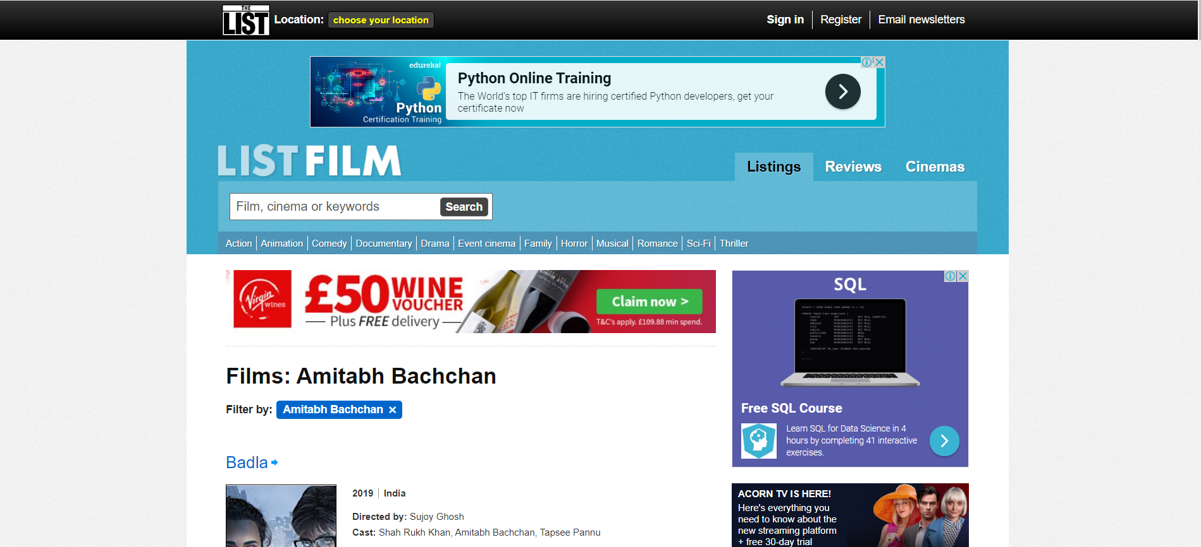

**Figure 2.1: Amitabh Bachchan Blog**

**Step 2:**Now we show the downloaded content (data is downloaded from Division area, All Picture, All Picture Name as Alt, All Headings and All Paragraphs) in a web page .

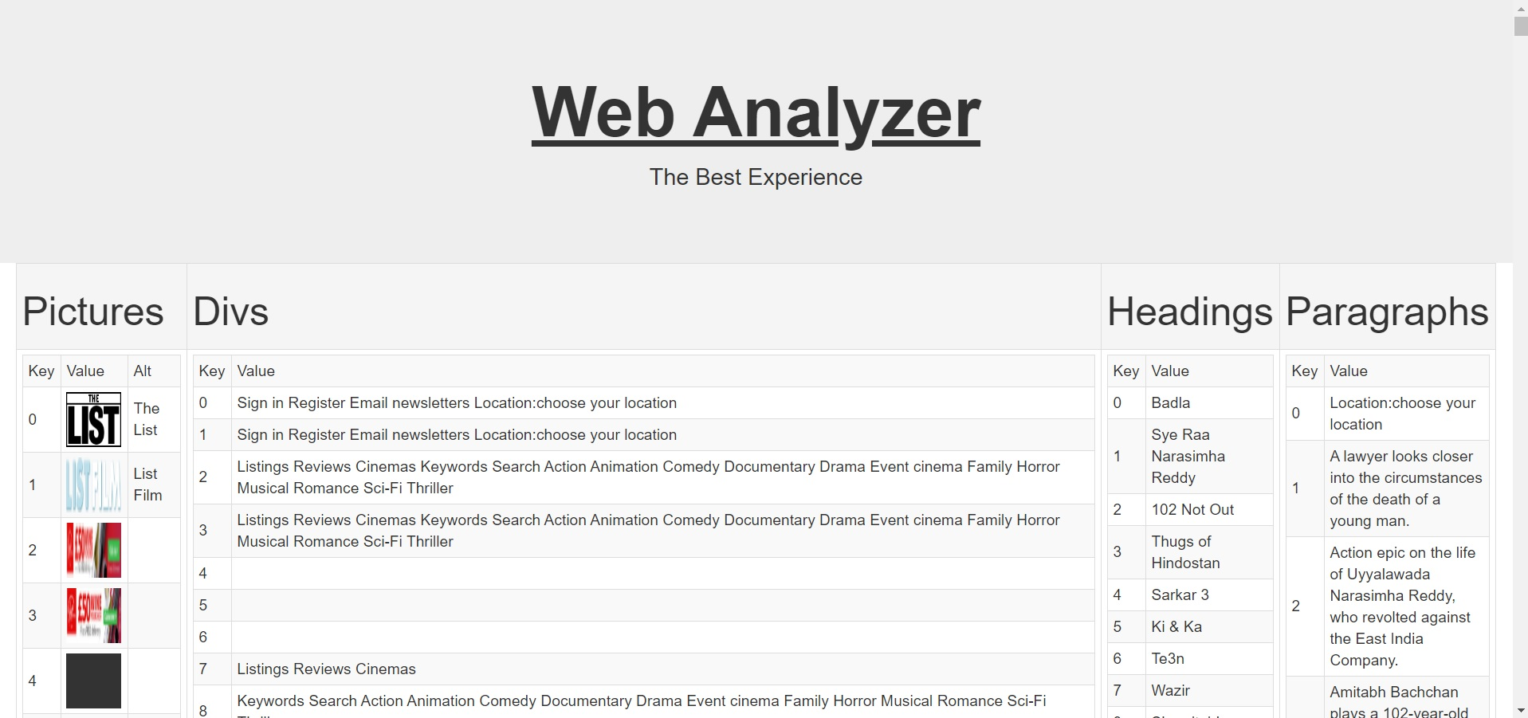

**Figure 2.2: Front page of site Web Analyzer**

**Step 3:** Now we produce a sentence list from the downloaded content.

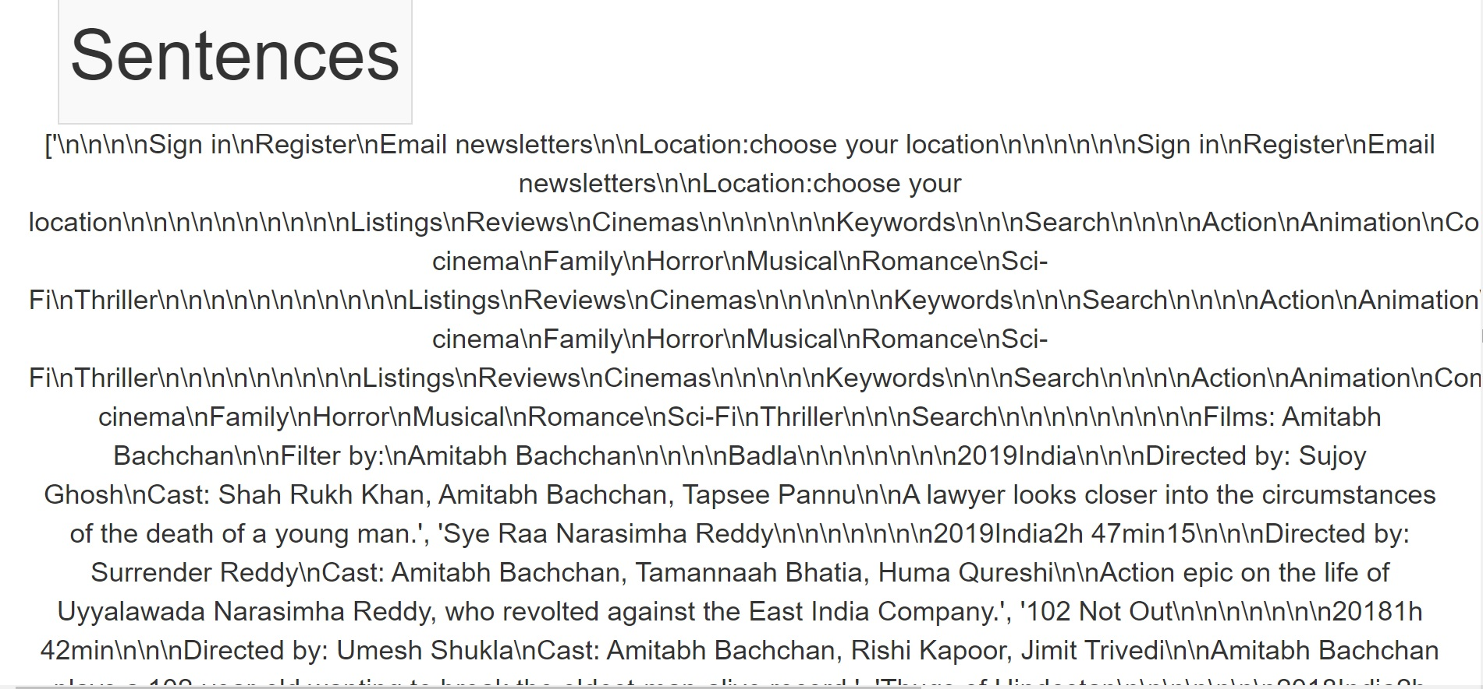

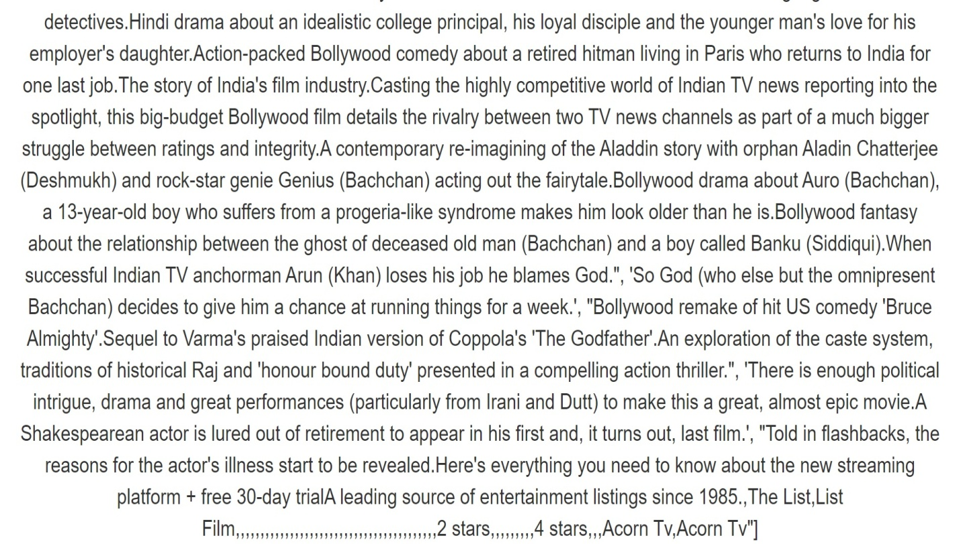

**Figure 2.3: Sentence list for Amitabh bachchan Blog**

**Step 4:-**Then we also produce a words list by downloaded content.

### C:\Users\vishal kumar\Desktop\Screenshot1\23.jpg

### C:\Users\vishal kumar\Desktop\Screenshot1\21.jpg

**Figure 2.4: Word list for Amitabh bachchan Blog**

### Step 5:- Now with the help of word list we make a words of frequency list shown in web page .

### C:\Users\vishal kumar\Desktop\Screenshot1\5.jpg

### C:\Users\vishal kumar\Desktop\Screenshot1\24.jpg

**Figure 2.5: Words of frequencies for Amitabh bachchan Blog**

**Step 6**: Now we simply plot a graph between words and its frequencies.

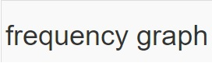

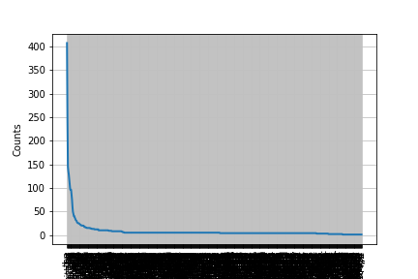

**Figure 2.6: frequency graph for Amitabh bachchan Blog**

**Step 7:** Now we make a list of stop words. This list helps to show the some irrelevant content of words.

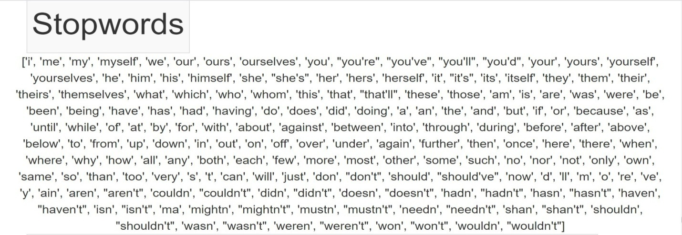

**Figure 2.7: Stopwords for Amitabh bachchan Blog**

**Step 8:** After we know all stop words we remove all stop words from the words list. And we create a new list of words. This list is shorter than actual word list, so this list is much efficient than previous word list.

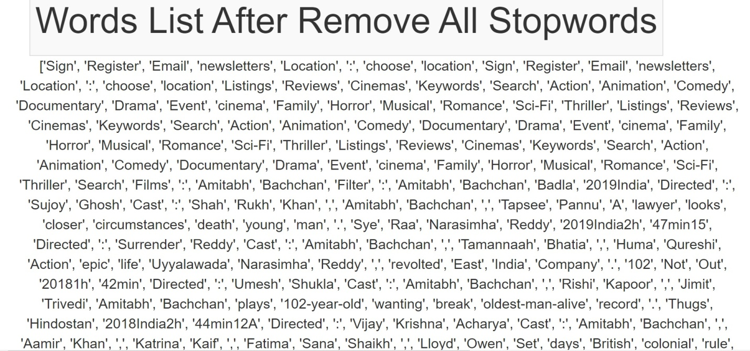

**Figure 2.8: Word list after remove Stopwords (Amitabh bachchan Blog)**

**Step 9:** Now we produce a dictionary of frequency and words with the help of Words List After removing all Stop words. This dictionary helps to know the frequency of words after the remove of stop words.

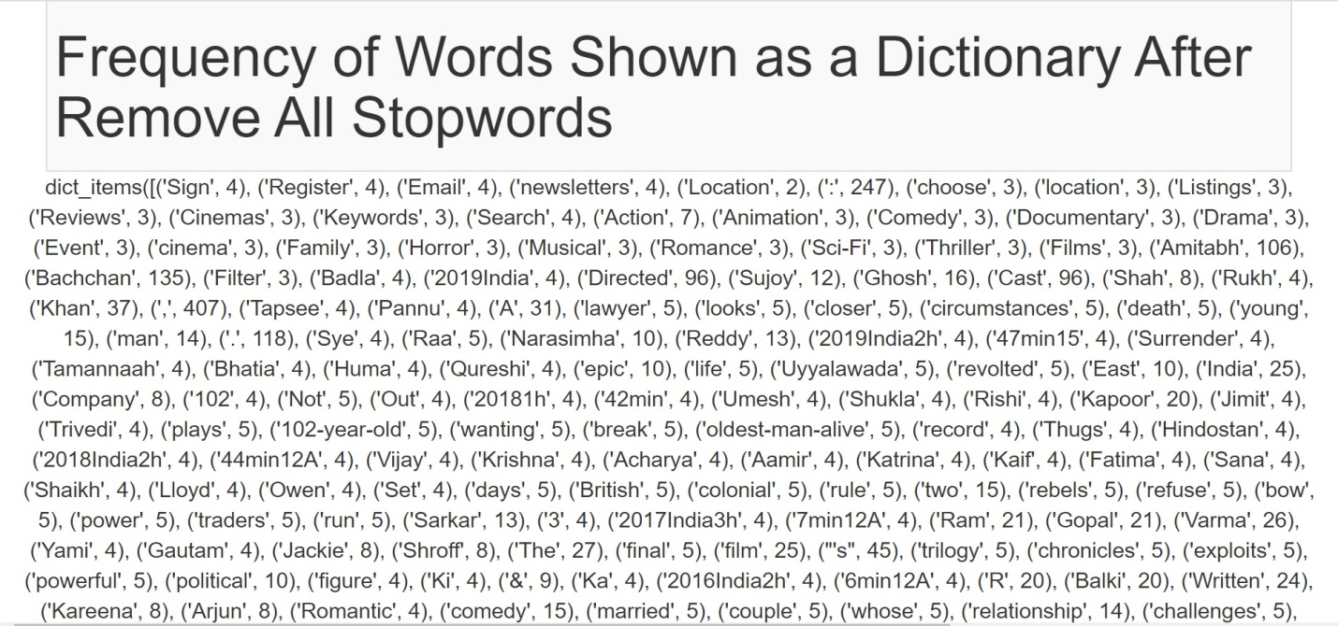

**Figure 2.9: Frequency dictionary for Amitabh bachchan Blog**

**Step 10**: Now we plot a graph between frequency and words after the removal of all stopwords.



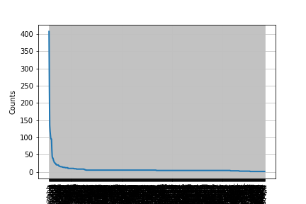

**Figure 2.10: Frequency graph after removing stopwords for Amitabh bachchan Blog**

**Step 11:** We need all words as Set hence we need to convert all words into Set. This Set will be used in next steps.

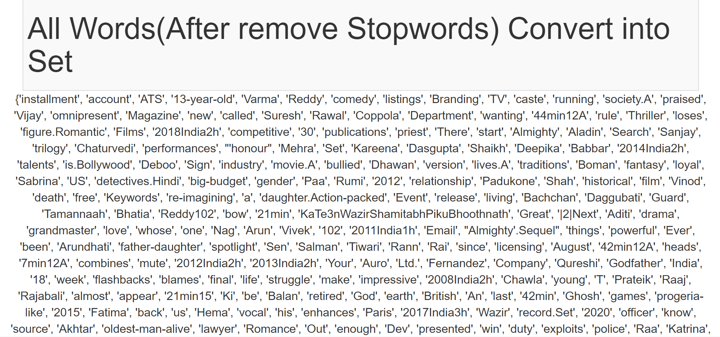

**Figure 2.11: Convert words list into Set for Amitabh bachchan Blog**

**Step 12:** Now we take a Training Set. We produce training set in project.

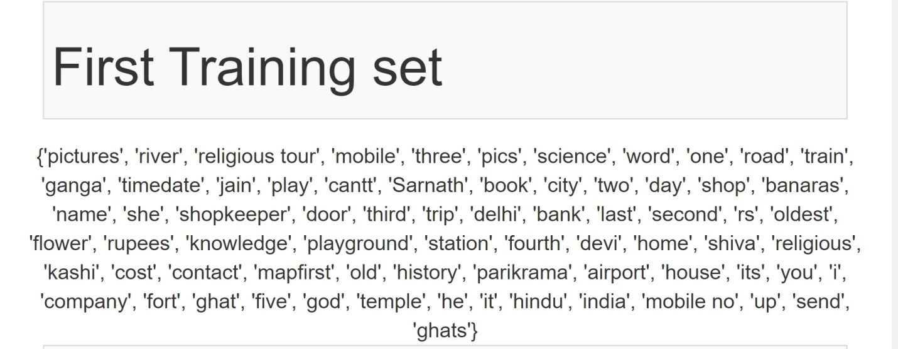

**Figure 2.12: First training Set for Amitabh bachchan Blog**

**Step 13:** Now we produce an intersection of training set from Step11 and words set from the above step10.

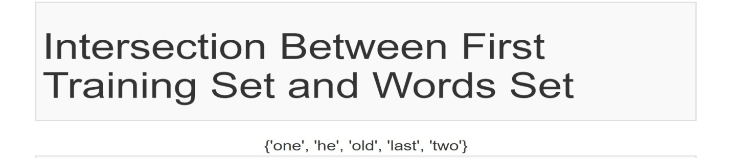

**Figure 2.13: Intersection Set for Amitabh bachchan Blog**

**Step 14:** After the produced intersection of sets now we will produce the frequencies of intersection set.

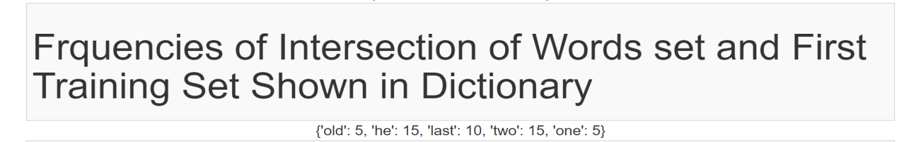

**Figure 2.14: Frequencies and words in Intersection Set for Amitabh bachchan Blog**

**Step 15:** Now we plot the graph between frequency and words of Intersection Set. This graph is produce in webpage of our project.



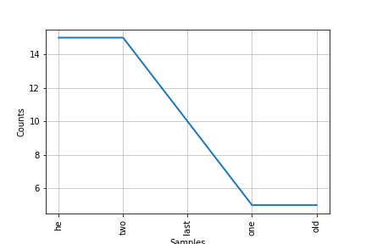

**Figure 2.15: Plot graph of Intersection Set 1for Amitabh bachchan Blog**

**Step 16:** Now we consider a different training Set. This is produced in project’s web page.

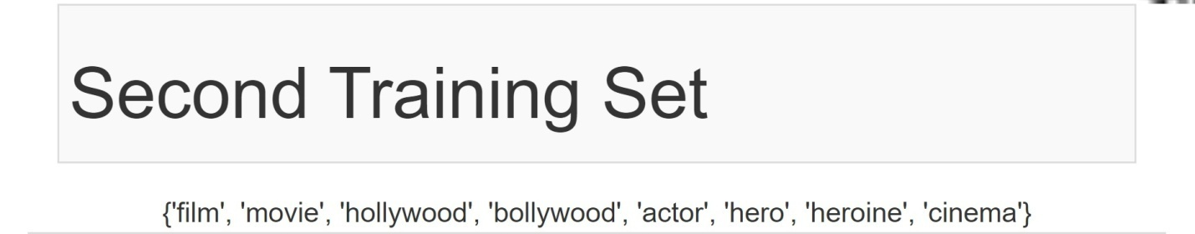

**Figure 2.16: Second training Set for Amitabh bachchan Blog**

**Step 17:** After we produce second training set we need to know the intersection of set of words set and this second training set .After we found intersection of words set and training set we produce the frequency of Intersection set.

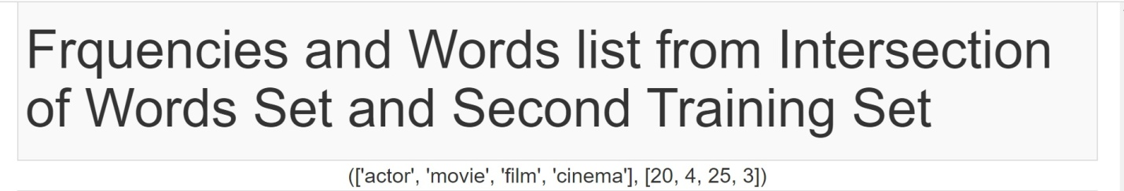

**Figure 2.17: Intersection Set2 for Amitabh bachchan Blog**

**Step 18:** When we found the frequency of intersection set then now we will plot the graph between frequency set and words set from the intersection set



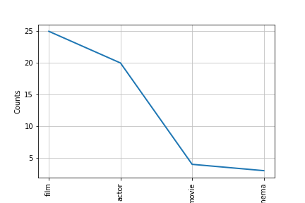

**Figure 2.18: Plot graph of Intersection Set2 for Amitabh bachchan Blog**

**Step:19**  Now we take a different url-“<http://varanasikshetra.com>” as input from web pages, Then we download the relevant content from the page. .

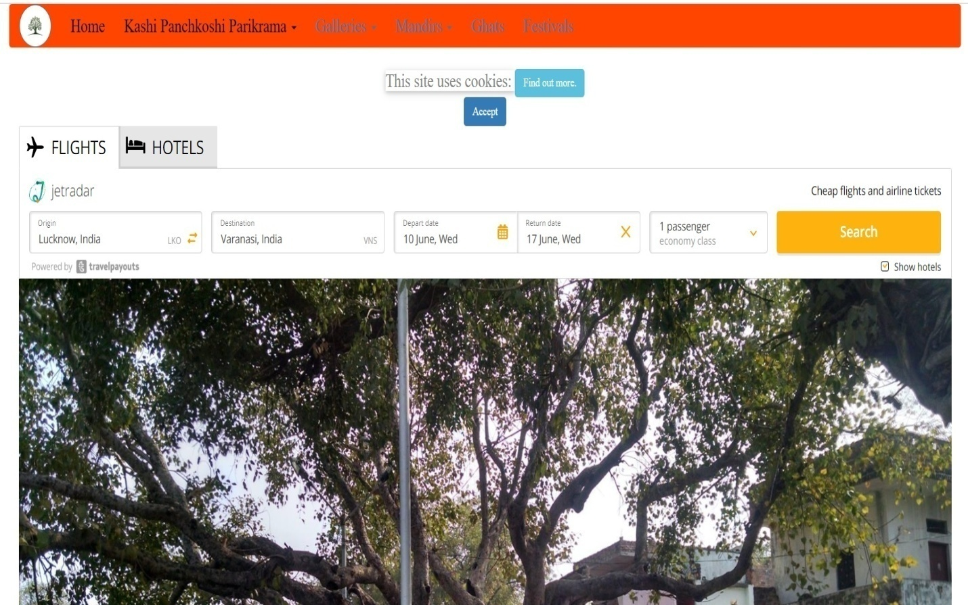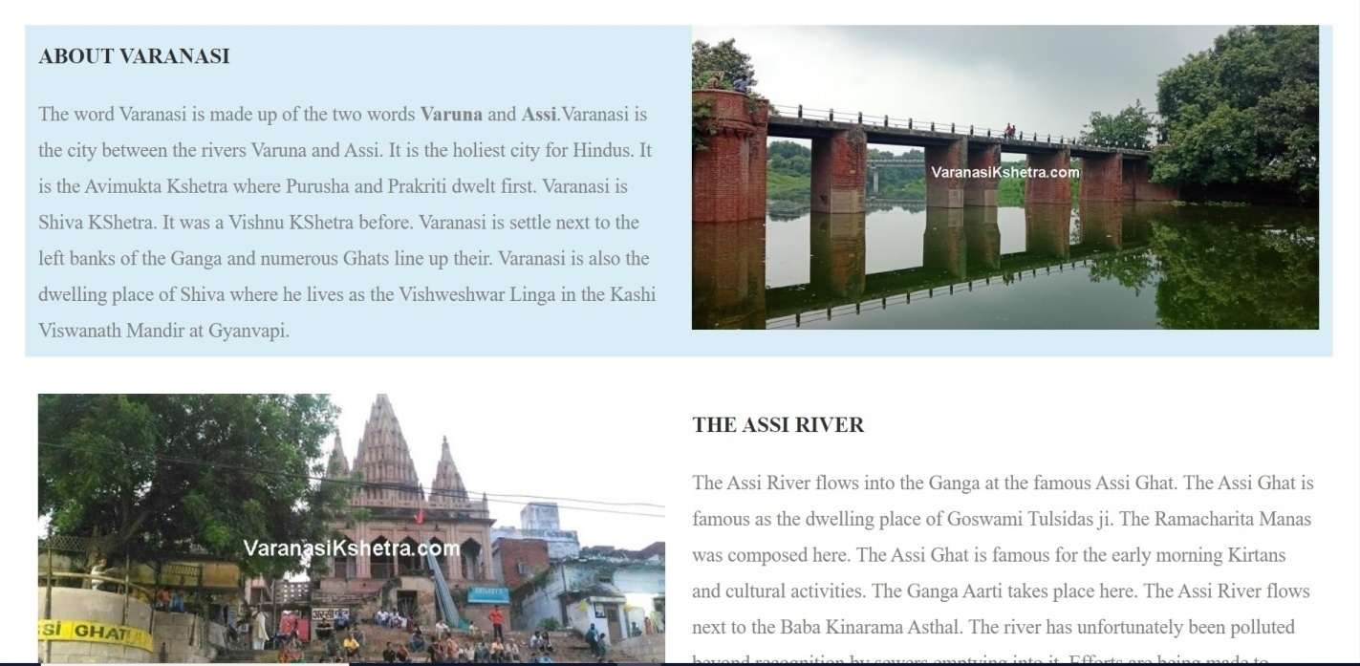

**Figure 3.1: Varanasikshetra**

**Step 20:** Now we show the downloaded content (data is downloaded from Division area, all Pictures, all Pictures Name as Alt, all Headings and all Paragraphs) in a web page .In this section(step) we produce the front page of Web Analyzer and create a table for store data from downloading content. In this section we represented all pictures data (images and image alt), divisions’ data, headings data and paragraphs data in column of the table. We can also count the how many data are available in headings, pictures, divisions and paragraphs by using key values of these contents.

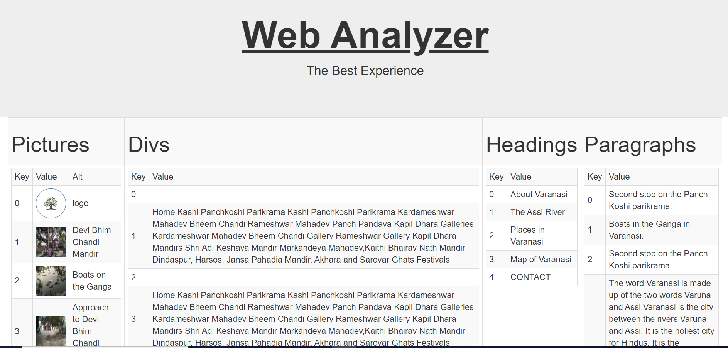

**Figure 3.2: Front page of site Web Analyzer (for Varanasikshetra)**

**Step 21:** Then we also produce a ‘Sentence list’ by downloaded content. In this section we join two pictures to explain the Sentence list. First picture explain starting part of the Sentence list and second picture explain the last past of Sentence list.

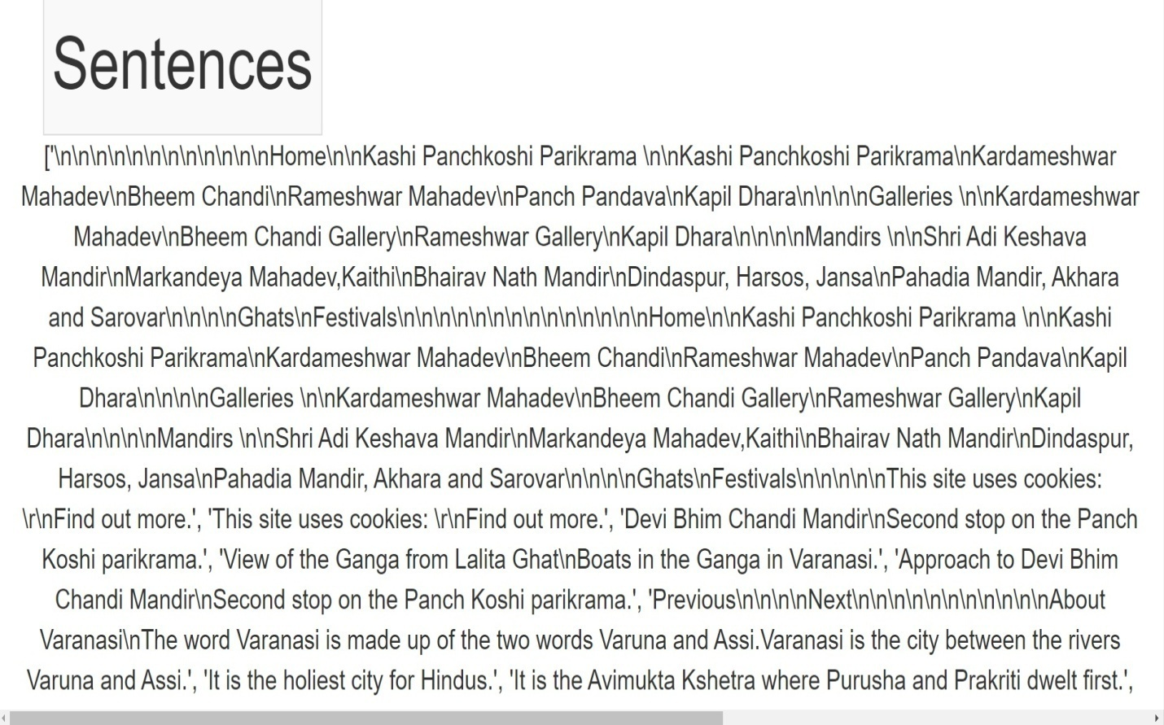

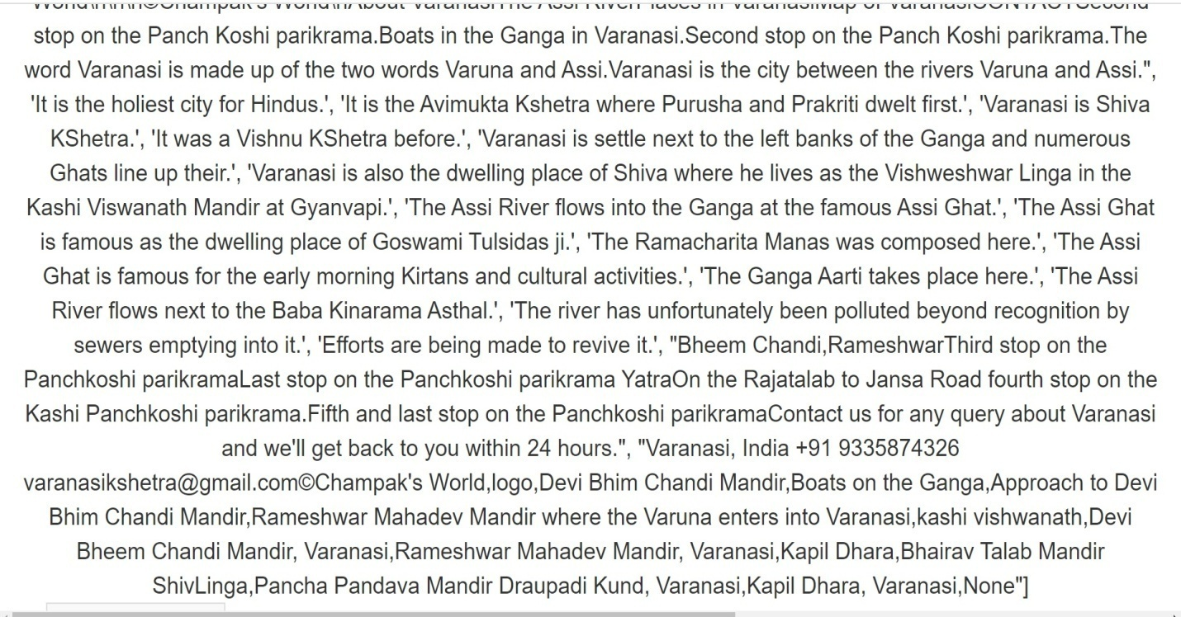

**Figure 3.3: Sentence list for Varanasikshetra website**

**Step 22:** Then we also produce a words list by downloaded content. In this section we join two pictures to explain the words list. First picture explain starting part of the words list and second picture explain the last past of words list.

### C:\Users\vishal kumar\Desktop\Screenshot1\32.jpg

### C:\Users\vishal kumar\Desktop\Screenshot1\33.jpg

**Figure 3.4: Words list for Varanasikshetra website**

### Step 23: Now with the help of words list we make words with frequency dictionary shown in this section .

### 

**Figure 3.5: Words of frequencies for Varanasikshetra website**

**Step 23**: Now we simply plot a graph between words and its frequency.



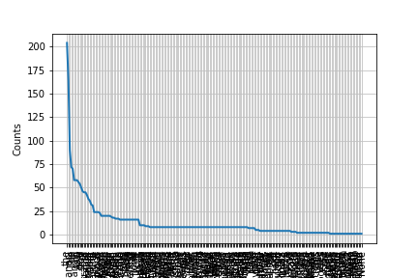

**Figure 3.6: frequency graph for Varanasikshetra Website**

**Step 24:** Now we make a list of stop words. This list helps to show some irrelevant content of words.

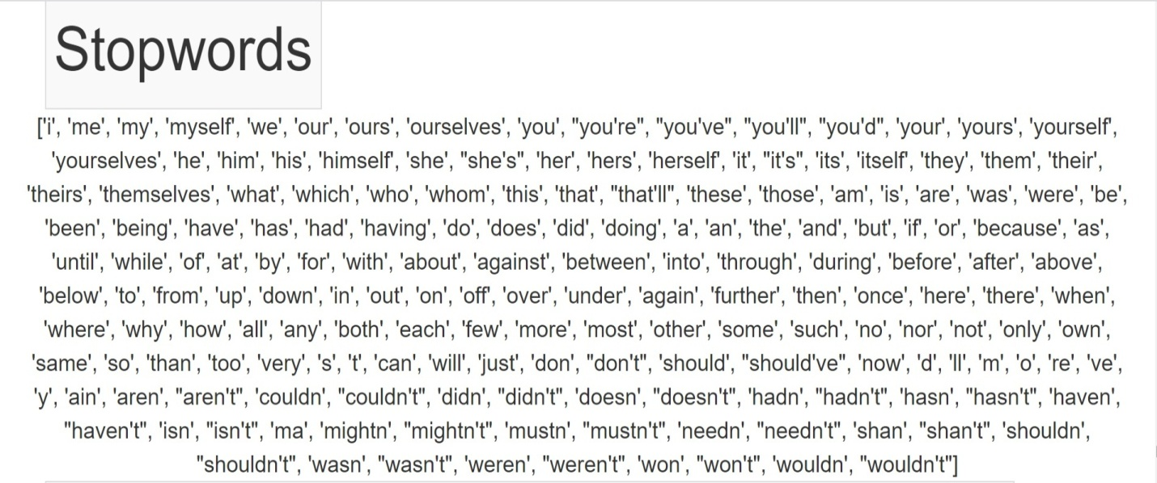

**Figure 3.7: Stopwords for Varanasikshetra**

**Step 25:** After we know all stop words we remove all stop words from the words list. And we create a new list of words. This list is shorter than actual word list, therefore this list is much efficient than previous words list. In this step we explain starting and last pictures of list (in this project).

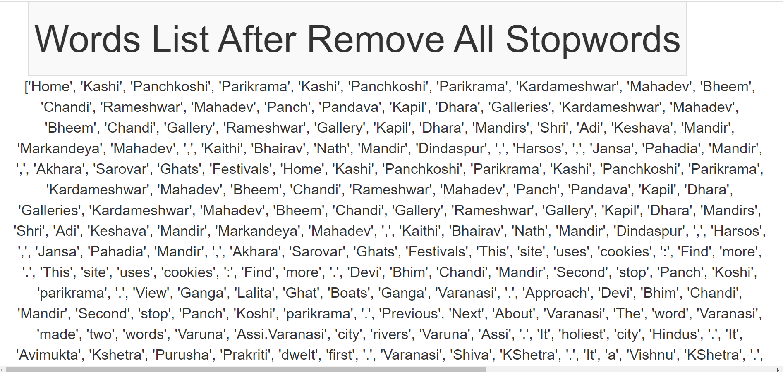

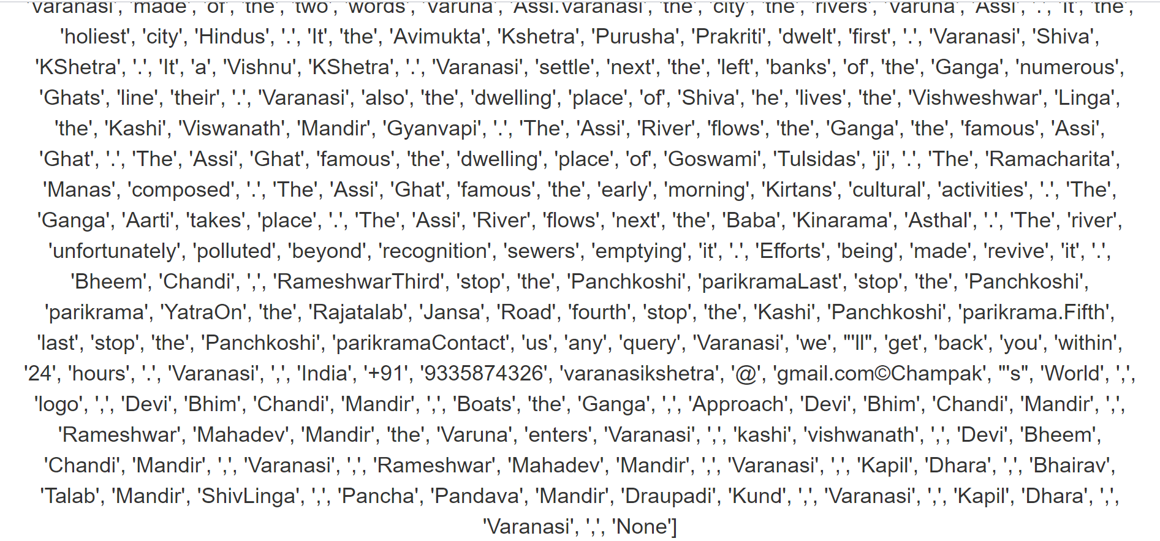

**Figure 3.8: Word list after remove Stopwords for Vanaransikshetra**

**Step 26:** Now we will produce a dictionary of frequency and words with the help of Words List. After removing all stop words. This dictionary helps to know the frequency of words after the removal of stop words.

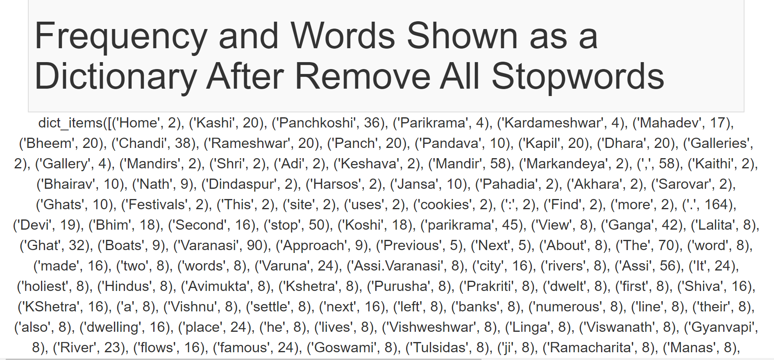

**Figure 3.9: Frequency Dictionary for Varanasikshetra website**

**Step 27**: Now we plot a graph between frequency and words after the removal of all Stopwords.



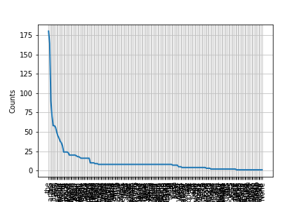

**Figure 3.10: Frequency graph after removing Stopwords for Varanasikshetra**

**Step 28:** We need all words as Set hence we need to convert all words into Set. This Set will be used in next steps. Note that in this section we show only some data in picture actual data which observe in project explain in this project.

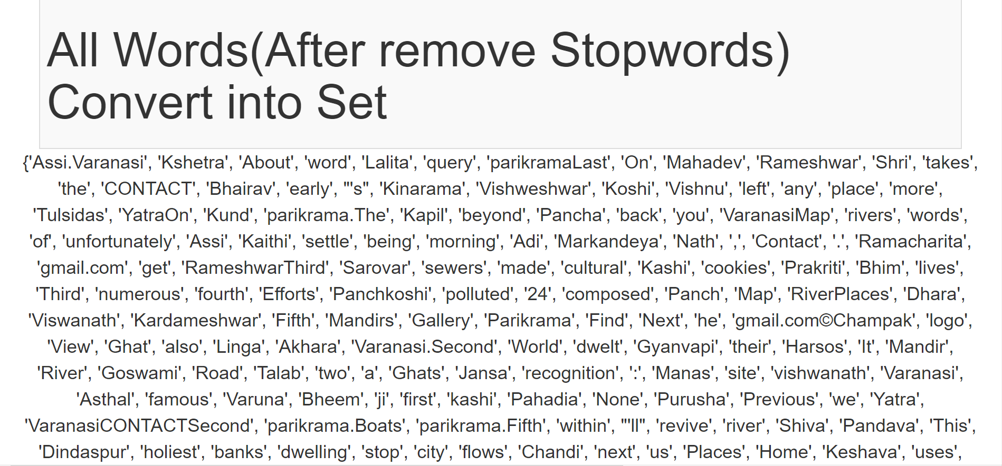

**Figure 3.11: Convert words list into Set for Varanasikshetra website**

**Step 29:** Now we take first Training Set, therefore we produce training set in a web page of this project.

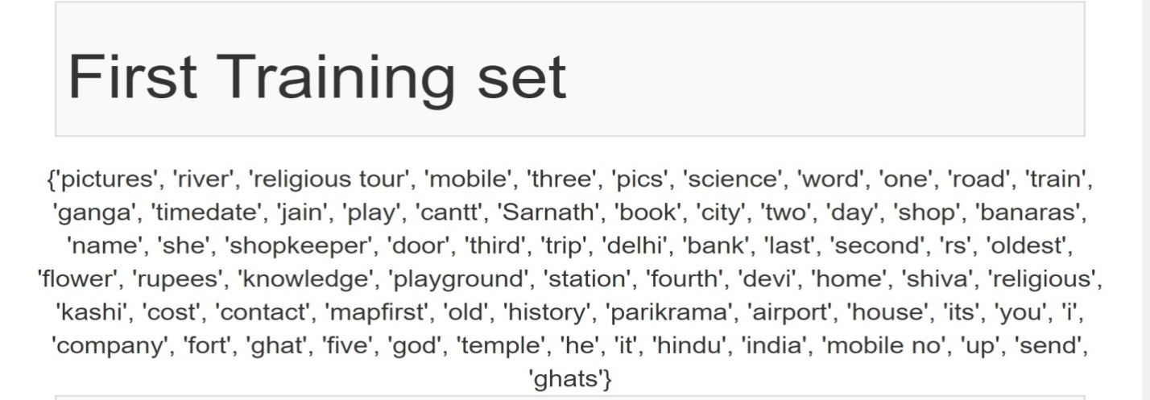

**Figure 3.12 First training Set for Varanasikshetra website**

**Step 30:** Now we produce an intersection of training set from Step29 and words set from the Step28.

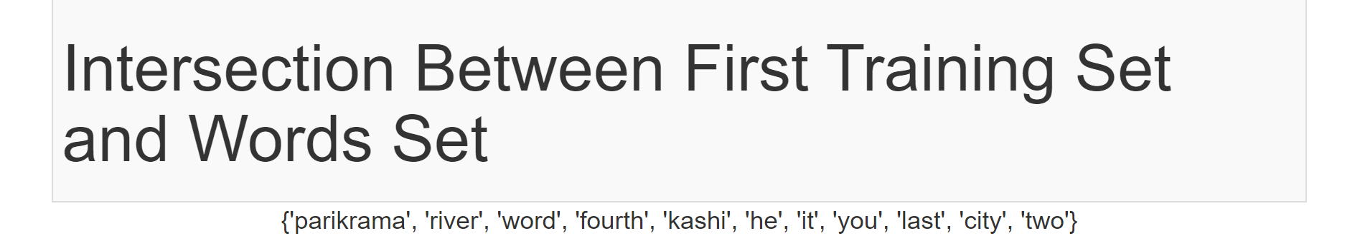

**Figure 3.13: Intersection Set for Varanasikshetra website**

**Step 31:** After we produce intersection of sets now we will produce the frequencies of intersection set.

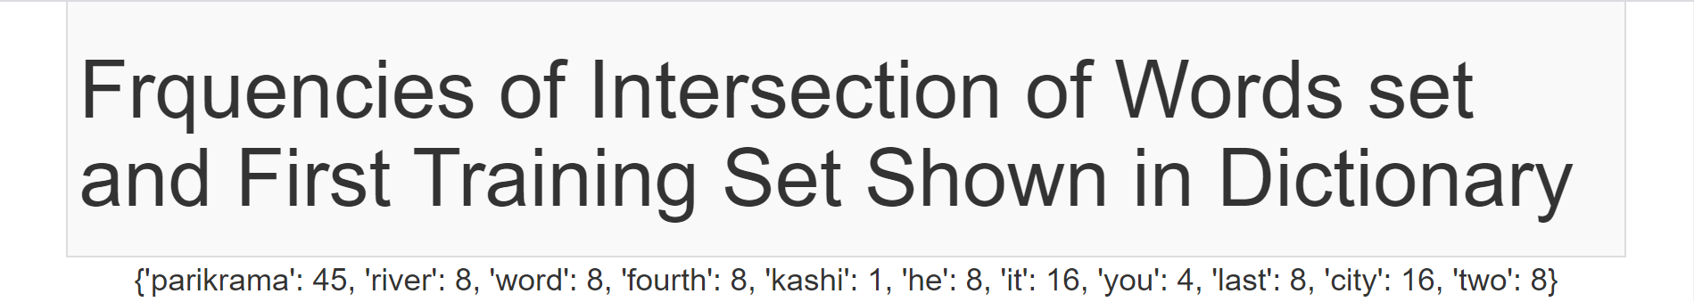

**Figure 3.14: Frequencies and words in Intersection Set for Varanasikshetra Website**

**Step 32:** Now we plot the graph between frequency and words of Intersection Set. This graph is produced in web page.



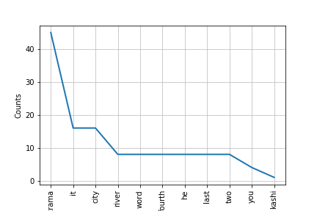

**Figure 3.15: Plot graph of Intersection Set1 for Varanasikshetra website**

**Step 33:** Now we consider different training Set. This is produced in web page of this project



**Figure 3.16: Second training Set for Varanasikshetra website**

**Step 34:** After we produce second training set we need to know the intersection set of words set and this second training set .After we found intersection of words set and training set we produce the frequency of Intersection set.

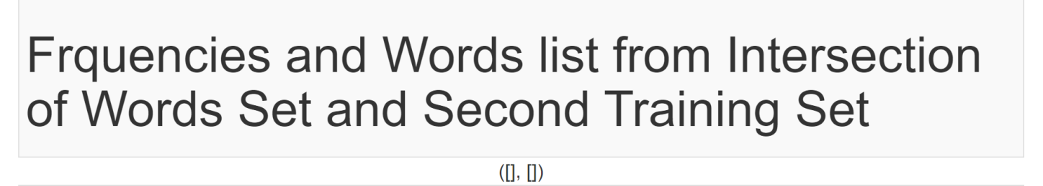

**Figure 3.17: Intersection Set2 for Varanasikshetra wabsite**

**Step 35:** When we found the frequency of Intersection set then we have already words set of

Intersection set. Now we will plot the graph between frequency set and words set from intersection set



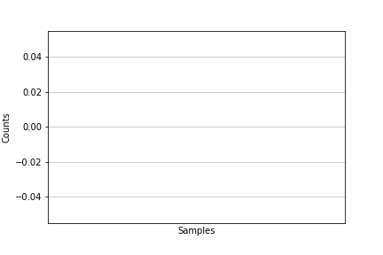

**Figure 3.18: Plot graph of Intersection Set2 for Vranasikshetra website**

**4.1 Future Scope:**

Consider the following scenarios.

1. You are running a web advertisement program like google ads where your company supplies appropriate ads on given pages. Pages would usually be based on the content of the page. You classify the page into certain categories and put a relevant ad.
2. Your company is into the data mining business. In this case you harvest information from the web, store it and provide the relevant information. You need to catalog, store, archive and present.
3. You work for a company that is developing a web search system. Not necessarily a general purpose web search but a targeted web search which keeps track of the lowest hotel booking rates for instance. You need web software that automatically detects hotel booking pages and also scrapes out the prices on those pages.
4. Finally you might want a tool that harvests semantic information from the web. For example you want to know the details of the flash on the latest Sony camera available on Amazon. You can feed the url of the Amazon reviews page and this software will harvest the relevant information.

**4.2 Result:**

The Web Analyzer project has been tested on the home page of <http://varanasikshetra.com> and <http://film.list.co.uk/listings/amitabh-bachchan/>" web page.

We consider first website link <http://film.list.co.uk/listings/amitabh-bachchan/>

For Analysis and Classify for webpage, the project has used two training sets, so we get two outcomes for two training sets ‘hindureligious’ and ‘movies’.

‘hindureligeous’ set has 5 similar words and ‘movies’ set has 8 similar words after finding the similarity between website (url) and training sets .So we say that as compare to ‘hindureligeous’ set as ‘movies’ set has more matched words .So we say that our best training set is ‘movies’ set.

Now we consider second website link <http://varanasikshetra.com>

For Analyze and Classify for webpage, the project has used two training sets, so we get two outcomes for two training sets ‘hindureligious’ and ‘movies’.

‘hindureligeous’ set has 11 similar words and whereas ‘movies’ set has no similar words after finding the similarity between website (url) and training sets .So we say that as compare to ‘movies’ set as ‘hinureligious’ set has more matched words .So we say that our best training set is ‘hindureligeous’ set.

Now Result is that for link first ‘movies’ set has more preferable and for second link ‘hindurelious’ set has more preferable.

**4.3 Conclusion:**

As mentioned above the project has been tested on two different urls. One of them is a Hindu religious site; the other is a film blog.

The analysis has been satisfactory. Information has been correctly downloaded, extracted , analyzed and classified. The results have been attached in the report.

The test results have been satisfactory and up to acceptable standards.

**REFERENCES**

1. <https://www.tutorialspoint.com/flask/index.html>
2. <https://www.w3schools.com/python/>
3. <https://www.python.org/>
4. <https://getbootstrap.com/>
5. <https://www.tutorialspoint.com/natural_language_processing/natural_language_processing_python.html>
6. <https://en.wikipedia.org/wiki/Web_scraping>
7. <https://matplotlib.org/tutorials/introductory/pyplot.html>